**DAILY ONLINE ACTIVITIES SUMMARY**

|  |  |  |  |  |  |  |  |  |
| --- | --- | --- | --- | --- | --- | --- | --- | --- |
| **Date:** | **02/07/2020** | | | | **Name:** | | **NAIPUNYA VINOD NAIK** | |
| **Sem & Sec** | **IV SEM & A SECTION** | | | | **USN:** | | **4AL18CS050** | |
| **Online Test Summary** | | | | | | | | |
| **Subject** | **NO INTERNALS CONDUCTED** | | | | | | | |
| **Max. Marks** | **----------------** | | **Score** | | | | **------------------** | |
| **Certification Course Summary** | | | | | | | | |
| **Course** | | **1) LINUX FOR ABSOLUTE BEGINNERS!**  **2) WEBINAR ON C++ PROGRAMMING** | | | | | | |
| **Certificate Provider** | | 1. **UDEMY** 2. **AIET** | | | | **Duration** | | **1)7.5 HRS**  **2)1.5HRS** |
| **Coding Challenges** | | | | | | | | |
| **Problem Statement: 1)** [Write a Java Program minimize the maximum difference between adjacent elements in an array](https://github.com/orgs/alvas-education-foundation/teams/2nd-year/discussions/144). | | | | | | | | |
| **Status: EXECUTED** | | | | | | | | |
| **Uploaded the report in Github** | | | | **YES** | | | | |
| **If yes Repository name** | | | | <https://github.com/naipunya-naik/lockdown-coding/blob/master/JAVA%20CODING/min%20max%20adjacent%20elements%20in%20array_02-07-2020> | | | | |
| **Uploaded the report in slack** | | | | **YES** | | | | |

Online Test Details: (Attach the snapshot and briefly write the report for the same)

NO INTERNALS CONDUCTED

Certification Course Details: (Attach the snapshot and briefly write the report for the same).

1)CERTIFICATION COURSE NAME:- LINUX FOR ABSOLUTE BEGINNERS!



TOPICS COVERED ON 02 JULY 2020:-

**Section 6: Web Development Project**

**Section 7: Web Server Setup, Host  
Configuration, and App Deployment**

**Section 8: Linux User Management**

**Section 9: Linux Network  
Administration**

HENCE I COMPLETED THIS CERTIFICATION COURSE.

2) WEBINAR ON C++ PROGRAMMING

* CONDUCTED BY:- MS. SHRUTHI SHETTY J,ASST.PROF,CSE DEPT.
* DURATION 1.5 HRS
* FROM 12.00 PM TO 1.30PM
* THE WEBINAR COMPRISED THE CONCEPTS OF CONSTRUCTOR , DESTRUCTOR , INHERITANCE, POLYMORPHISM,QUIZ.
* HERE ARE THE SCREENSHOTS OF TODAY’S WEBINAR.
* 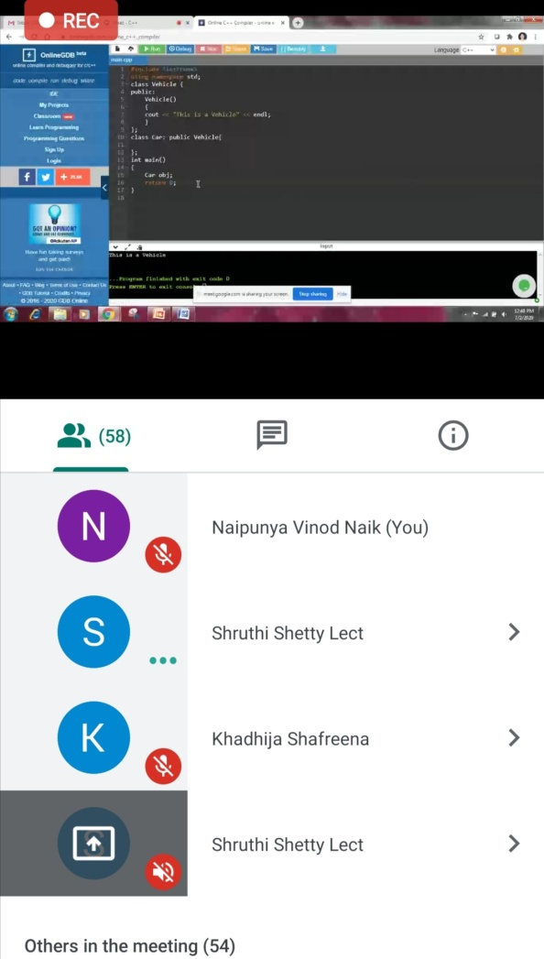 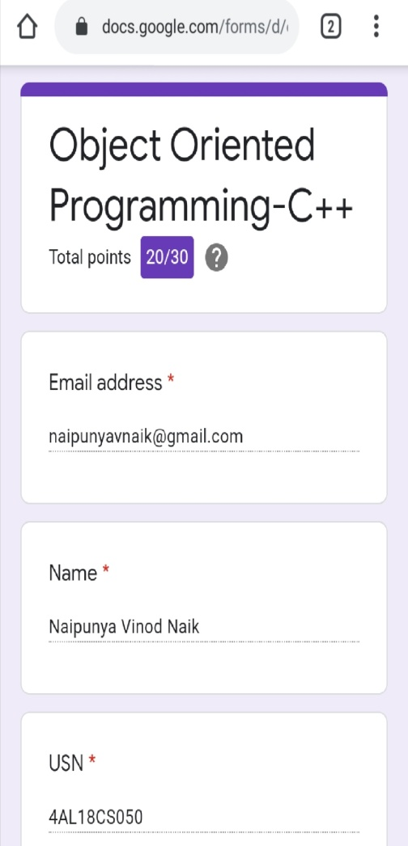

Coding Challenges Details: (Attach the snapshot and briefly write the report for the same)

**PROBLEM STATEMENT :-Write a Java Program minimize the maximum difference between adjacent elements in an array.**

**Top of Form**

**Bottom of Form**

|  |
| --- |
| **Given a non-decreasing array arr[] and an integer K, the task is to remove K elements from the array such that maximum difference between adjacent element is minimum.**  **Note: K < N – 2**  **Examples:**  **Input: arr[] = {3, 7, 8, 10, 14}, K = 2 Output: 2 Explanation: After removing elements A[0] and A[4], The maximum difference between adjacent elements is minimum. After removing elements, the remaining array is [7, 8, 10]** |

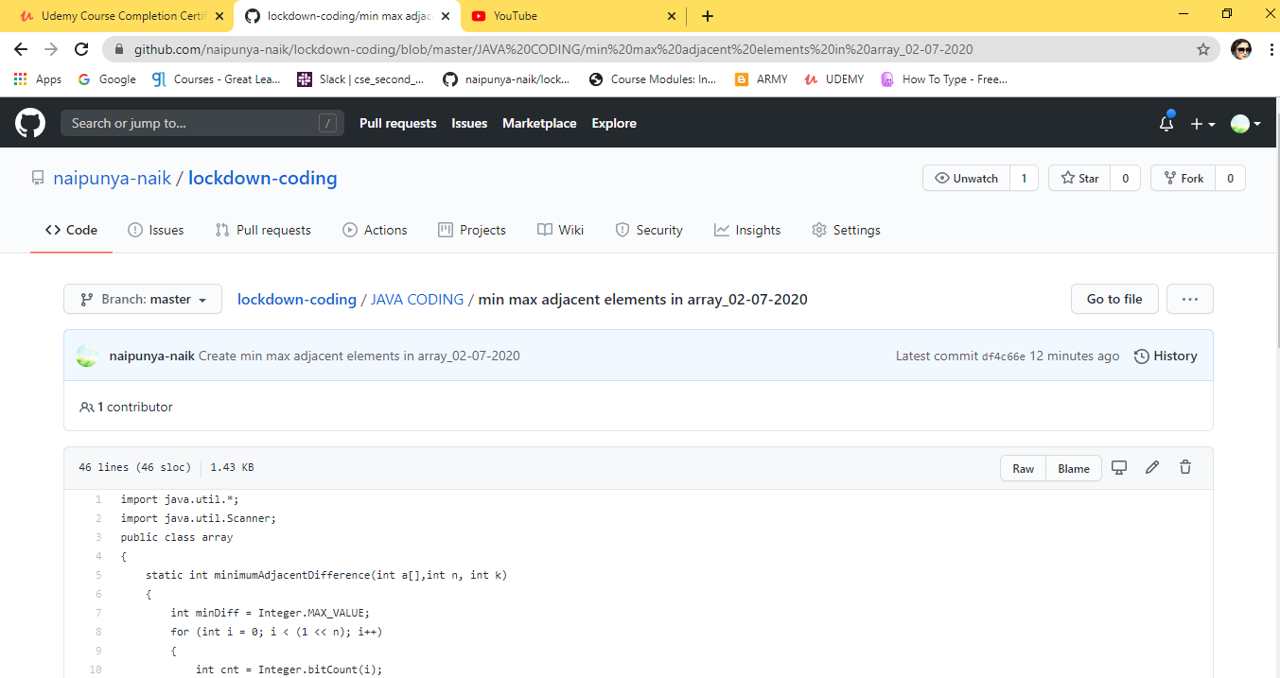

GITHUB REPOSITORY LINK:-

<https://github.com/naipunya-naik/lockdown-coding/blob/master/JAVA%20CODING/min%20max%20adjacent%20elements%20in%20array_02-07-2020>